Practical lesson 3 : Morphology and classification of Spirochetes, Rickettsia, Chlamydia, Mycoplasma and Actinomycetes. Giemsa staining.

Morphology and Ultrastructure of Spirochaetes.
Genetically spirochaetes (L. spira curve, Gk. chaite cock, mane) differ from bacteria and fungi in structure with a corkscrew spiral shape. The body of the spirochaete consists of an axial filament and cytoplasm wound spirally around the filament. No special membrane separates the nucleoid from the cytoplasm. Spirochaetes have a three-layer outer membrane. As demonstrated by electron microscopy, they possess a fine cytoplasmic membrane enclosing the cytoplasm. The spirochaetes do not possess the cell wall characteristic of bacteria, but electron microscopy has revealed that they have a thin cell wall (periplast) which encloses the cytoplasm (Fig.42). Spirochaetes do not produce spores, capsules, or flagella. Very delicate terminal filaments resembling flagella have been revealed in some species under the electron microscope.
In spite of the absence of flagella, spirochaetes are actively motile due to the distinct flexibility of their bodies. Spirochaetes have a rotating motion which is performed axially, a translational motion forwards and backwards, an undulating motion along the whole body of the microorganism, and a bending motion when the body bends at a certain angle.
Some species stain blue, others blue-violet, and still others — pink with the Giemsa stain. A good method of staining spirochaetes is by impregnation with silver. Staining properties (reaction to stains) are used to differentiate between saprophytic and pathogenic representatives of spirochaetes.
Classification of spirochaetes. The order Spirochaetales, family Spiro-chaetaceae includes the sprophytes (Spirochaeta, Cristispira) representing large cells, 200-500 mсm long, some of which have crypts (undulating crests); the ends are sharp or blunt. They live on dead substrates, in foul waters and in the guts of cold-blooded animals. They stain blue with the Giemsa stain.
Three pathogenic genera belong to the family Spirochaetaceae:
- Borrelia,
- Treponema,
- Leptospira.
The organisms of genus Borrelia differ from spirochaetes in that their cells have large, obtuse-angled, irregular spirals, the number of which varies from 3 to 10. Pathogenic for man are the causative agents of relapsing fever transmitted by lice (Borrelia recurrentis) and by ticks (Borrelia persica, etc.). These stain blue-violet with the Giemsa stain.
The genus Treponema (Gk. trepein turn, пета thread) exhibits thin, flexible cells with 6-14 twists. The micro-organisms do not appear to have a visible axial filament or an axial crest when viewed under the microscope. The ends of treponemas are either tapered or rounded, some species have thin elongated threads on the poles. Electron microscopy of ultrathin treponema sections revealed a thin, elastic and poorly resistant membrane composed of lipids, poliosides, and proteins. The cytoplasmic membrane lends the treponemas a spiral shape. Besides the typical form, there may be treponemas seen as granules, cysts, L-forms, and other structures. The organisms stain pale-pink with the Giemsa stain. A typical representative is the causative agent of syphilis Treponema pallidum.
Organisms of the genus Leptospira (Gk. leptos thin, speira coil) are characterized by very thin cell structure. The leptospirae form 12 to 18 coils wound close to each other, shaping small primary spirals. The organisms have two paired axial filaments attached at opposite ends (basal bodies) of the cell and directed toward each other. The middle part of the leptospirae have no axial filament. Due to the presence of the two pairs of axial filaments the leptospirae are capable of quite complex and active movement. During movement the ends of the organisms rotate rapidly at a right angle to the main part of their body. At rest the ends are hooked while during rapid rotary motion they resemble buttonholes. Secondary spirals give the leptospirae the appearance of brackets or letter S. The cytoplasm is weakly refractive. They stain pinkish with the Giemsa stain. Some serotypes which are pathogenic for animals and man cause leptospirosis.

Giemsa staining procedure:
Thin blood films (only)
1. Fix air-dried film in absolute methanol by dipping the film briefly (two dips) in a Coplin jar containing absolute methanol.
2. Remove and let air dry.
3. Stain with diluted Giemsa stain (1:20, vol/vol) for 20 min. For a 1:20 dilution, add 2 ml of stock Giemsa to 40 ml of buffered water in a Coplin jar. 4. Wash by briefly dipping the slide in and out of a Coplin jar of buffered water (one or two dips). Note: Excessive washing will decolorize the film.
5. Let air dry in a vertical position.
Thick blood films (only)
1. Allow film to air dry thoroughly for several hours or overnight. Do not dry films in an incubator or by heat, because this will fix the blood and interfere with the lysing of the RBCs. 2. DO NOT FIX.
3. Stain with diluted Giemsa stain (1:50, vol/vol) for 50 min. For a 1:50 dilution, add 1 ml of stock Giemsa to 50 ml of buffered water in a Coplin jar.
4. Wash by placing film in buffered water for 3 to 5 min.
5. Let air dry in a vertical position

Morphology and Ultrastructure of Rickettsiae
Rickettsiae are included in the order Rickettsiales of obligate intracellular bacteria containing DNA and RNA and are pleomorphic organisms. They live and multiply only within the cells (in the cytoplasm and nucleus) of the tissues of humans, animals, and vectors.
Coccoid forms resemble very fine, homogeneous, or single-grain ovoids about 0,5 mcm in diameter, quite often they occur as the diploforms. Rod-shaped rickettsiae are short organisms from 1 to 1,5 mcm in diameter with granules on the ends; or long and usually curved thin rods from 3 to 4 mcm in length. Filamentous forms are from 10 to 40 mcm and more in length; sometimes they are curved and multigranular filaments.
Rickettsiae are non-motile, do not produce spores and capsules and stain well by the Giemsa stain and the Ziehl-Neelsen stain.
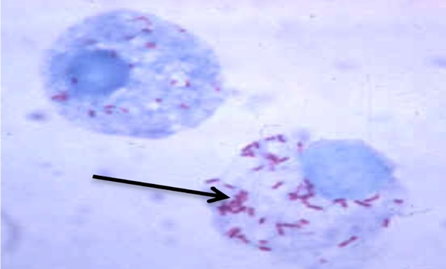Figure 46. Rickettsiae (Giemsa stain)

Electron microscopy and cytochemical study have shown that the rickettsiae have an inner (0,06 mcm) and an outer membrane acting as a wall and consisting of three layers. Granules of the ribosome type measuring 2-7 mcm and vacuole-like structures 0,06-0,08 mcm in diameter have been found in the cytoplasm or rickettsiae.
Ricketsiae multiply by division of the coccoid and rod-shaped forms wich give rise to homogeneous populations of the corresponding type, and also by the breaking down of the filamentous forms giving rise to coccoid and rod-shaped entities.
Pathogenic rickettsiae invade various species of animals and man. The diseases caused by rickettsiae are known as rickettsioses. A typical representative is Ricckettsia prowazekii (the name was given in honour of the scientists, the American Howard Ricketts and Czech Stanislaus Prowazek), the causative agent of typhus fever.
Ricketsiae pertain to obligate parasites. They live and multiply only in the cells (in the cytoplasm and nucleus) or animals, humans, and vectors.
The order Rickettsiales consists of 3 families:
- Rickettsiaceae, wich has been characterized above;
- Bartonellaceae, parasites of human erythrocytes;
- Anaplasmaceae, parasites of animal erythrocytes.

Morphology and Ultrastructure of Chlamydia
The order Chlamydiales includes the family Chlamydiaceae, genus Chlamydia; these are the causative agents of ornithosis, trachoma, venereal lymphogranuloma and other diseases.
The chlamydial cell is roughly spherical and measures between 0.3 and 1.0 u in diameter, according to the stage of development. Both the small and the large cell types contain complete cell walls which are similar to the cell walls of gram-negative bacteria. Chlamydia are non-motile, do not produce spores and capsules and multiply in the cytoplasm of the host cell. The chlamydia, are obligate intracellular parasites of higher animals (mammals and birds). These organisms are termed basophilic because they take up the Giemsa stain (i.e., they stain blue) (Fig.47).
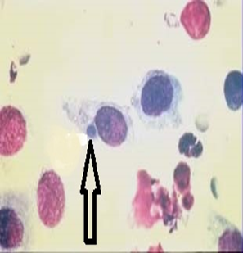Figure 47. Inclusion of Chlamydia (Giemsa stain)
Under the cell wall lies a separate cytoplasmic membrane made up of large amounts of lipid. The DNA occurs as an irregular mass in the cytoplasm. There is no nuclear membrane. Ribosomes can be seen throughout the cytoplasm.
The chlamydia fall into two main ecological groups. In the first group, are the agents causing trachoma, inclusion conjunctivitis and lymphogranuloma venereum (Chlamydia trachomatis), atipical pneumonia (Chlamydia pneumoniae) which seem to infect man only. In the second group, are those agents transmitted to man as zoonotic infections. About 100 species of birds are naturally infected with chlamydia. This includes 71 species of parrots as well as finches, pigeons, chickens, ducks, turkeys and seabirds (Chlamydia psittaci).

Morphology and Ultrastructure of Mycoplasmas
The mycoplasmas belong to the class Mollicutes, order Mycoplasmatales. These bacteria measure 100-150 nm, sometimes 200-700 nm, are non-motile and do not produce spores.
Mycoplasmas are the smallest microorganisms. They were first noticed by Pasteur when he studied the causative agent of pleuropneumonia in cattle. However, at the time he was unable to isolate them in pure culture on standard nutrient media, or to see them under a light microscope. Because of this, these micro-organisms were regarded as viruses. In 1898 Nocard and Roux established that the causative agent of pleuropneumonia can grow on complex nutrient media which do not contain cells from tissue cultures. Elford using special filters determined the size of the microbe to be within the range of 124-150 nm. Thus, in size mycoplasmas appeared to be even smaller then some viruses.
Since they do not possess a true cell wall, mycoplasmas are characterized by a marked pleomorphism. They give rise to coccoid, granular, filamentous, cluster-like, ring-shaped, filterable forms, etc (Fig.48). Pleomorphism is observed in cultures and in the bodies of animals and man.
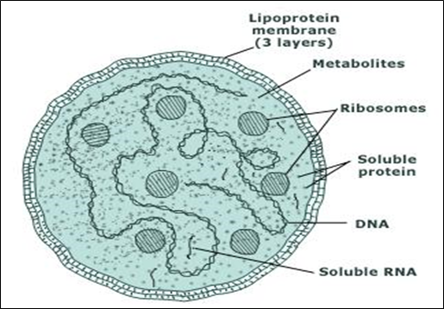Figure 48. Structure of Mycoplasma cell

No two forms are alike. The nuclear apparatus is diffuse. There are both pathogenic and non-pathogenic species. The most representative of the pathogenic species in the causative agent of pleuropneumonia in cattle (see section on pathogenic mycoplasmas).
At the present time more then 36 representatives of this order have been isolated, the most minute of all known bacteria. They are found in the soil, sewage waters, different substrates and in the bodies of animals and humans. Since mycoplasmas pass through many filters, and yet grow on media which do not contain live tissue cells, they are considered to be micro-organisms intermediate between bacteria and viruses. Chemically, micoplasmas are closer to bacteria. They contain up to 4 per cent DNA and 8 per cent RNA.
The most typical representatives of the pathogenic species are the causative agents of pleuropneumonia in cattle (Mycoplasma mycoides), acute respiratory infections (Mycoplasma hominis), and atypical pneumonia in humans (Mycoplasma pneumoniae).
Morphology and Ultrastructure of Actinomycetes
Actinomycetes (Gk. mykes fungus, actis ray) are unicellular micro­organisms which belong to the class Bacteria, the order Actinomycetales. The body of actinomycetes consists of a mycelium which resem­bles a mass of branched, thin (0.2-1.2 mcm in thickness), non-septate, filaments — hyphae.
In some species the mycelium breaks up into poorly branching forms. In young cultures the cytoplasm in the cells of actinomycetes is homo­geneous, it refracts light to a certain extent, and contains separate chromatin grains. When the culture ages, vacuoles appear in the mycelial cells, and granules, droplets of fat and rod-shaped bodies also occur. The cell wall becomes fragile, breaks easily and a partial lysis of the cells occurs. In actinomycetes, as in bacteria, differentiated cell nuclei have not been found, but the mycelial filaments contain chromatin granules. The actinomycetes multiply by means of germinating spores attached to sporophores, and by means of fragmen­tation where they break up into hyphae (Fig.49).
The order Actinomycetales consists of 4 families: Mycobacteriaceae, Actinomycetaceae, Streptomycetaceae, Actinoplanaceae. The family Mycobacteriaceae includes the causative agents of tuberculosis, leprosy, and the family Actinomycetaceae, the causative agents of actinomycosis
and acid-fast species nonpathogenic for man.
Among the actinomycetes of the family Streptomycetaceae are representatives which are capable of synthesizing antibiotic substances.These include producers of streptomycin, chloramphenicol, chlortetracycline, oxytetracycline, neomycin, nystatin, etc. No species pathogenic for animals and man are present in the family Actinoplanaceae.
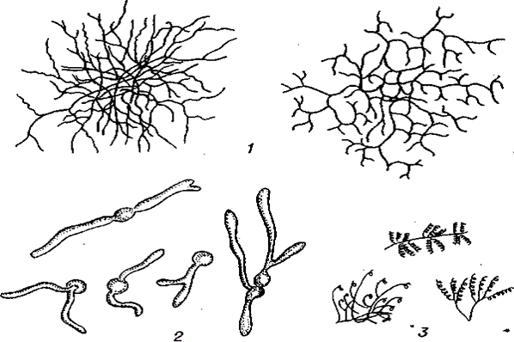Figure 49.
Morphology and structure of actinomycetes. 1-general view of the mycelium; 2—germination of spores; 3 — structure of sporophores

